AI Brand Operator — Concept Whitepaper v2
Oct 28, 2026 · @AURELIEN
v2 · Oct 29, 2026 · VJ, building on Aurélien's v1 of Oct 28, 2026
How to read v2
Aurélien's v1 text is unchanged. My responses sit in three kinds of box.
- Comment (blue): where I agree, refine or correct.
- Question (amber): where we need a decision at the founders' session. Lettered A to E and collected at the end.
- Vision (green): where I build on the concept.
New sections at the end set out the stack, the consignment and entity model, the ERP approach, the open questions, and a summary of what changed from v1.

Executive summary
A subscription platform where a brand plugs in its product and goals, and AI runs its online business end to end, does not exist yet in the UK or EU. Adjacent players are moving fast, so the window is roughly 12 to 24 months.
- Model: brands subscribe; the platform never buys or holds stock, and the brand stays seller of record.
- Gap: competitors either own stock and use large teams (Pattern), cover one channel (Lumian, Amazon's and Shopify's free agents), or one function.
- Wedge: a market-entry autopilot that takes consumer health and beauty brands live on UK and EU marketplaces.
- Next: a 12-week team workplan to answer seven critical questions before building at scale (final section).
VJ · Comment
Agree with the model, the gap and the timing. One reframing I want us to adopt: this is not an online business. It is a CPG operating company as a service. We provide the operating layer of a CPG company, and brands plug into it.
Online marketplaces are where we start, because that is where retailers now look for proof before they list a product in store. They are not the boundary of the business. The stack section at the end sets out how I see the layers.

The problem
Good products stall because commercial execution is expensive, slow and fragmented.
- Selling online needs many specialists per channel: listings, ads, pricing, stock, logistics, service, compliance and finance.
- Full-service Amazon agencies charge $3,000 to $15,000+ a month or 3% to 15% of sales, usually for one channel (Ecom Brainly).
- Entering a new country adds compliance (for example EU GPSR), localisation and VAT, so many products never leave their home market.
VJ · Comment
Agree. From running a supplement brand on Amazon and from CPG commercial finance, I would add that the hidden cost is not only the specialists per channel. It is the operating backbone underneath: order to cash, procure to pay, finance, stock and cash visibility. Small and mid-size brands run this on spreadsheets and goodwill.
That backbone is what we should own, with the channel work on top of it.

The concept
An AI brand operator: the brand subscribes, sets its goals, and the platform runs the business across every online channel.
- The brand: sets targets, budget, positioning and red lines; ships stock to FBA or a 3PL; approves exceptions.
- The platform: channel set-up, listings, ads, pricing, forecasting, customer service, compliance checks and reporting.
- Asset-light: no stock bought or held; the brand keeps its stock, books and liability.
- Option: live data across brands creates a later option to invest in the best performers.
It sells the work, not the software: companies spend about $6 on services for every $1 on software (Lumian).
VJ · Comment
Refinement to "asset-light": stock is held, but on consignment. The brand stays the legal owner, the stock never sits on our balance sheet, and we house it in our own warehouse and bill for that service. We get physical control of fulfilment and a second revenue line without the Thrasio balance-sheet risk.

VJ · Question
Question A. Who is seller of record on each marketplace in each geography: the brand, or our local entity? This decides VAT, product liability, customer data, and whether a brand can plug out cleanly. It also shapes the entity design in the new sections.

How it works
The brand sets goals and ships stock once; an orchestrator then directs specialized agents across every channel, with guardrails and a small expert bench for exceptions.
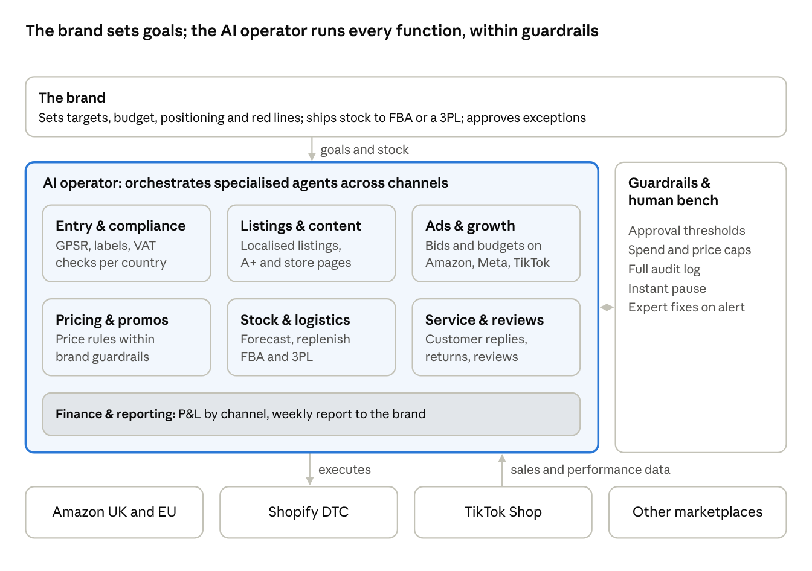
how it works · brand, AI operator, channels
Data flows back from every channel, so agents learn across all brands. Anything outside the brand's guardrails is escalated for approval.
VJ · Vision
The orchestrator and agents in this diagram are the top of a deeper stack. Underneath them I see an ERP configured to run a complete CPG company, and a knowledge graph of how CPG processes work end to end, which the agents draw on. ERP plus knowledge graph plus agents is the harness. Brands plug into the harness, and the harness does not change when a brand leaves.
The seven agent boxes map onto ERP process domains. Entry and compliance, stock and logistics, and finance and reporting sit on procure to pay, order to cash and finance. Listings, ads, pricing and service sit on the GTM channel layer. Category management is the insights and analytics function.

Competitive landscape: does it exist?
Partly. The pieces exist in four groups, but no one offers a near-touchless, multi-channel, all-function operator for small and mid-size brands in Europe. The open space is the top-right corner.
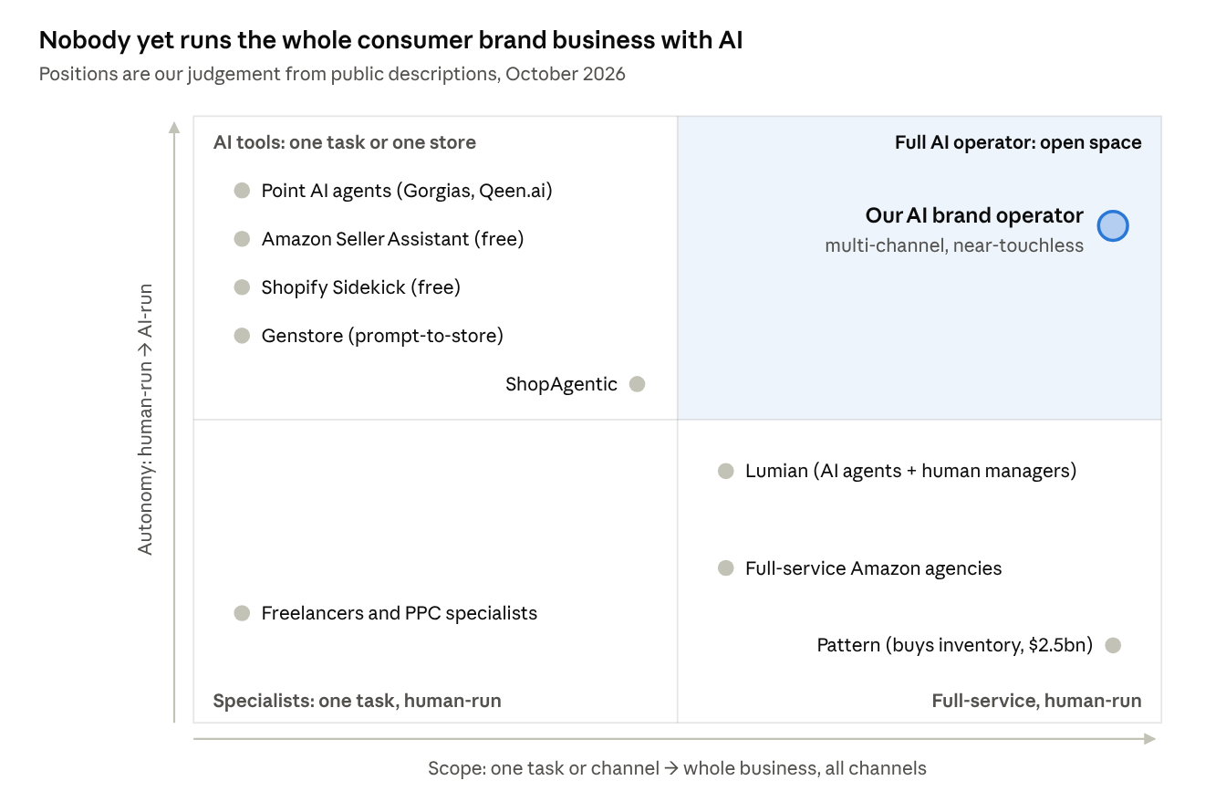
market map · scope × autonomy
Player | Model | Gap versus our concept
Pattern | Buys and resells brands' stock on 70+ marketplaces; $2.5bn revenue in 2025 | Owns stock; human-heavy; large brands
Lumian | AI-native Amazon agency; $3M seed, April 2026 | Amazon only; humans own decisions; US
ShopAgentic | Agents run catalogue, pricing, service, fulfilment; €1.9M pre-seed (Germany) | One store, not multi-channel brand operation
Amazon Seller Assistant, Shopify Sidekick | Free agents inside each platform | One channel each
Point agents (Gorgias, Qeen.ai), Genstore | One function, or DTC store launch | Narrow scope
Aggregators (Thrasio) | Bought brands, largely with debt | Chapter 11 in 2024
VJ · Comment
The map is right for the online operator view. In the harness view, the scope axis runs past "all online channels" to the whole operating company, including physical retail. Nobody on the map sits there either.

VJ · Question
Question B. Should we add ERP vendors and their CPG partners (Dynamics 365, NetSuite, the open-source ERPs) to the map? They own the backbone we plan to build on, and we should know whether any of them is moving towards an operator model.
Question C. Do we treat retailers' own online platforms (Walmart Online, Tesco Online) as a channel group of their own? Retailers increasingly use them to test products before listing in store, which makes them the bridge from digital proof to physical distribution.

Key risks
Risk | Mitigation
Amazon and Shopify give single-channel agents away free | Win on cross-channel orchestration, market entry and commercial judgement; use their agents underneath
Brands won't hand over the keys | Guardrails, approval thresholds, audit log, instant pause
Full autopilot isn't ready yet | Launch as AI plus a small expert bench; drive human minutes per £ of sales down
Category regulation (supplements, cosmetics, GPSR) | Start with categories we know; automate compliance checks; partner for the EU responsible person
Part-time team against funded rivals | Agree commitments and a full-time trigger early
VJ · Comment
Two of these risks get easier with the harness model.
- Brands won't hand over the keys: consignment plus one legal entity per geography means a brand sees its own siloed stock, cash and P&L for that country. That is more visibility than most get from an agency today.
- Full autopilot isn't ready: the ERP runs the transactions deterministically and the agents sit on top, so "human minutes per £ of sales" becomes measurable by process.
- One risk to add, ERP platform dependency: licence cost per brand per geography and the vendor's own AI roadmap both matter. Julien to weigh in.

Wedge
Start as a market-entry autopilot for consumer health and beauty brands on UK and EU marketplaces.
- Why: a sharp, painful job; it plays to the team's expertise; the platforms' own agents don't take a brand into five countries.
- Sequence: Amazon UK, then Amazon DE, FR, IT, ES; then Shopify DTC and TikTok Shop; then more categories; then any consumer brand.
- First customers: non-EU brands entering Europe, European brands stuck in one market, corporates testing a new country, and founder-sellers who want to step back.
VJ · Comment
Agree with consumer health and beauty, and with Amazon UK first. Two additions to the sequence.
- Channel focus: one or two channels for now, Amazon and Shopify or D2C. Walmart Online, Tesco Online and eBay form the next ring, and the harness channel layer should be built so that adding one is configuration, not a project.
- Physical retail: once a brand has digital traction in a geography, the next step is offline retail entry in that same geography, run through the same harness with an agentic ERP layer handling the physical expansion. Retailers now want online proof before they list in store, so this is the natural extension of the wedge, not a different business.

Business model
Priced against the agency or in-house team it replaces; exact levels to be tested.
- Onboarding fee per country or channel.
- Monthly subscription tiered by channels and countries.
- Performance fee as a % of sales, below the 3% to 15% agencies charge.
Margins should rise with each new brand as human time per brand falls. Any later investment in brands stays optional, equity-funded and separate: the Thrasio lesson.
VJ · Comment
Add a fourth revenue line: a warehousing and fulfilment service fee on consigned stock. And price the whole offer against the full operating cost a brand carries today, people, agencies, 3PL and software, not the agency alone.

VJ · Question
Question D. Target customer. I have mid-market and small branded CPG players in mind, roughly $500k to $1bn revenue. The assessment section says roughly £1 to 20m. Where do we draw the line for the first pilots, and does the upper end change what the harness must support (multi-entity, multi-currency, audit)?

Founding team
Founder | Brings | Likely role
Aurélien Villemonteix | International market entry and e-commerce for consumer health brands | commercial and go-to-market
VJ | CPG commercial finance (Reckitt); runs a supplement brand on Amazon | Operations and brand P&L; first pilot account
Julien Villemonteix | CEO of UpSlide, B2B SaaS; former CTO who wrote its original code | Product and technology; potential investor
The gap is a full-time AI engineering lead.
VJ · Comment
Agree the gap is a full-time AI engineering lead. I would add ERP platform selection to Julien's remit explicitly, since it is the first build decision and the hardest to reverse.

Our assessment and the critical questions
Verdict: a good idea with good timing and strong team fit. The biggest danger is trying to build the full vision at once.
- Strengths: no one owns multi-channel AI brand operation in Europe; the team covers commerce, CPG finance and SaaS; the subscription model avoids stock and debt risk.
- Concerns: "touchless" is the destination, not the launch, because brands pay for results and accountability; the customer sweet spot is narrow (roughly £1–20m brands, plus corporates testing new countries); a part-time team faces funded full-time rivals; the platforms will keep commoditising single-channel tasks.
Team workplan: 12 weeks to answer the critical questions (owners are proposals)
# | Critical question | How we answer it | Owner | Weeks
1 | Which 5 brands would pay for a pilot? | Shortlist 30 brands; 20–30 interviews; landing page with indicative prices | Aurélien, VJ | 1–4
2 | What one thing would a brand buy on its own? | Rank pain points from interviews; test market entry, ads and full operations as offers | Aurélien | 2–5
3 | Build our own agents or orchestrate existing tools? | Map each task to available tools and APIs; prototype the top 3 tasks | Julien | 2–6
4 | Do we take a performance fee and accountability for results? | Model pricing and liability scenarios; test them in pilot contracts | VJ | 3–6
5 | How much really runs without people? | Run 3–5 paid pilots concierge-style; log every human intervention | All | 5–12
6 | Is consumer health and beauty the right start? | Compare demand and compliance effort by category | VJ, Aurélien | 4–10
7 | Who goes full-time, who funds, and are employer conflicts cleared? | Agree commitments, equity, IP and funding; check permissions with current employers | All | 1–3
Decision at week 12: go (raise a pre-seed round and hire an AI engineering lead), narrow to what worked, or stop.
- ☐ Share this paper with VJ and Julien
- ☐ Hold a founders' session to agree the workplan and owners
- ☐ Start the brand shortlist and interview guide
VJ · Comment
Question 3 in the workplan: I would widen it from "build our own agents or orchestrate existing tools" to "which ERP do we build the harness on". We should not build an ERP from scratch. Candidates: Microsoft Dynamics 365, NetSuite, or an open-source ERP built for AI-native workflows. Criteria: cost per brand per geography for a $500k to $1bn brand, CPG fit out of the box, API and agent friendliness, multi-entity support, and the vendor's AI roadmap. Julien owns the selection.
Question 5 in the workplan: fix the metric now: human minutes per £ of sales, logged by process domain, so the pilots tell us where the harness is weakest.

VJ · The stack
How I see the platform, bottom up. The harness is a general-purpose engine. Brands plug in and plug out.
- ERP layer: an existing ERP configured to run a complete CPG company: order to cash, procurement and procure to pay, finance, GTM, and category management, which doubles as the insights and analytics function. GTM inside the ERP means specific online sales channels only for now: Amazon and Shopify first, then Walmart Online, eBay and others.
- Knowledge graph: how CPG processes work end to end, captured so that agents can act on it: process maps, annual cycles, margin profiles, trade terms, compliance rules by geography.
- AI operator layer: the orchestrator and specialised agents from the "How it works" diagram, operating the ERP through the knowledge graph, within the guardrails Aurélien describes.
- The harness: ERP plus knowledge graph plus agents. It is everything a CPG company is apart from the brand: supply chain, GTM strategy, sales mechanism and negotiation, financial metrics, annual cycles, margin profiles, media strategy.
- Brands: the products that are sold. They plug into the harness and plug out again. Brand A today, brand B tomorrow, with nothing brand-specific left behind in the harness.
- Geographies: one geography is one legal entity is one siloed instance, so every brand has full visibility of its financials per country.
The analogy is Amazon Web Services for CPG: the harness is the region and its services; each brand is a customer account.

VJ · Consignment and entities
- Stock is consigned. The brand remains legal owner. We never carry it on our balance sheet. We house it in our warehouse and bill a warehousing and fulfilment fee.
- Each geography has its own legal entity. That keeps VAT, compliance and financials siloed, and gives a brand clean numbers for that market.
- Still open: seller of record per marketplace (Question A), and own warehouse versus partner 3PL in each geography (Question E).

VJ · ERP approach
We configure, we do not build. The ERP is bought and configured with standard CPG settings, and the AI enablement is built on top.
- Candidates: Microsoft Dynamics 365, NetSuite, or an open-source ERP built for AI-native workflows.
- Target customer for cost and fit: mid-market and small branded CPG players, roughly $500k to $1bn revenue.
- Selection criteria: cost per brand per geography, CPG fit out of the box, API and agent friendliness, multi-entity support, vendor AI roadmap.
- Owner: Julien, as part of a widened workplan question 3.

VJ · Open questions for the founders' session
- A. Who is seller of record on each marketplace in each geography: the brand or our local entity?
- B. Do we add ERP vendors and their CPG partners to the market map?
- C. Do we treat retailers' own online platforms (Walmart Online, Tesco Online) as a channel group of their own?
- D. Target customer size for the first pilots: $500k to $1bn, or the paper's £1 to 20m?
- E. Own warehouse or partner 3PL in each geography?

VJ · Summary of changes from v1
- Reframed the concept from online business to CPG operating company as a service (executive summary, concept).
- Replaced "never holds stock" with consignment: the brand owns, we warehouse and bill (concept, business model).
- Added the stack under the orchestrator: ERP, knowledge graph, agents; brands plug in; one legal entity per geography (how it works, new sections).
- Extended the wedge: focused channels now, physical retail as the next step in the same geography (wedge).
- Widened workplan question 3 to ERP platform selection, owned by Julien, and proposed a fixed metric for question 5 (assessment).
- Added a fourth revenue line and a question on target customer size (business model).
- Added one risk: ERP platform dependency (key risks).

